**WEEK-2**

Task-2

**Step 1 code:**

CREATE TABLE Employees (

EmployeeID INT IDENTITY(1,1) PRIMARY KEY,

FirstName VARCHAR(50),

LastName VARCHAR(50),

DepartmentID INT,

Salary DECIMAL(10,2),

JoinDate DATE

);

INSERT INTO Employees (FirstName, LastName, DepartmentID, Salary, JoinDate) VALUES

('Raj', 'Verma', 1, 60000.00, '2022-01-15'),

('Priya', 'Sharma', 2, 75000.00, '2021-06-10'),

('Anjali', 'Mehta', 4, 58000.00, '2023-03-20'),

('Amit', 'Patel', 5, 82000.00, '2020-11-05'),

('Sneha', 'Reddy', 6, 72000.00, '2024-02-01'),

('Rahul', 'Singh', 7, 79000.00, '2019-08-25'),

('Kavita', 'Nair', 8, 61000.00, '2023-07-12'),

('Arjun', 'Mishra', 9, 70000.00, '2022-09-03');

**OUTPUT;**

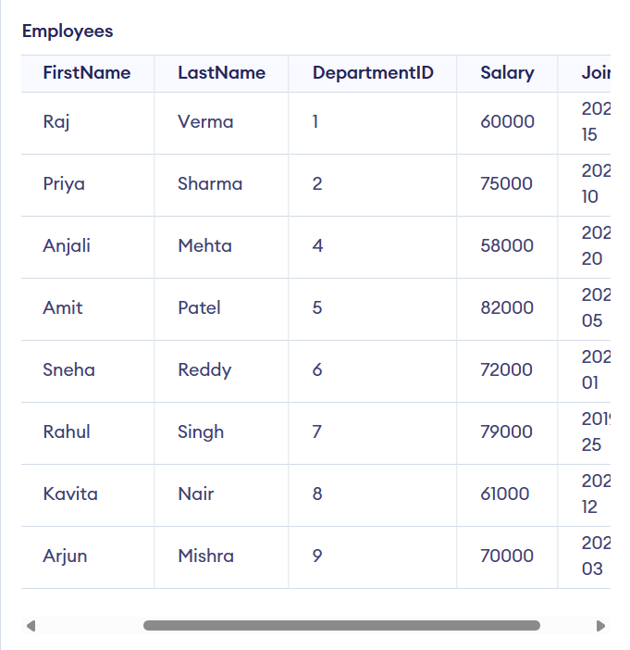

**Step 2 query:**

SELECT * FROM Employees WHERE DepartmentID = 2;

**OUTPUT:**

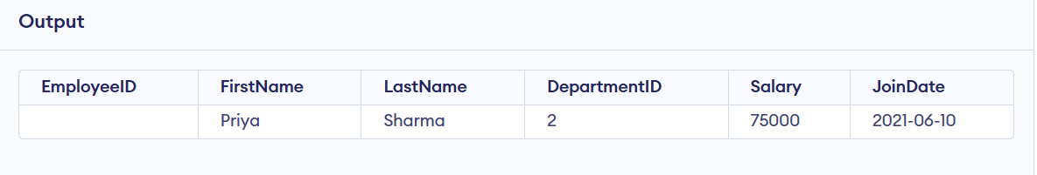

**Step 3 query:**

INSERT INTO Employees (FirstName, LastName, DepartmentID, Salary, JoinDate)

VALUES ('Ayushman', 'Upadhyay', 2, 55000.00, '2025-06-28');

**OUTPUT:**

